

**Green University of Bangladesh**

**Department of Computer Science and Engineering (CSE)**

**Faculty of Sciences and Engineering**

**Semester: (Fall, Year:2024), B.Sc. in CSE (Day)**

**Lab Report NO #02**

**Course Title: Web Programming Lab**

**Course Code: CSE-302 Section: 221 D13**

**Lab Experiment Name: Creating and Displaying My Class Routing Using HTML.**

**Student Details**

| **Name** | | **ID** |
| --- | --- | --- |
| **1.** | Tanvir Ahmed | 221002461 |

**Lab Date : 11/9/2024**

**Submission Date : 18/9/2024**

**Course Teacher’s Name : Kazi Hasnayeen Emad**

| **Lab Report Status**  **Marks: ………………………………… Signature:.....................**  **Comments:.............................................. Date:..............................** |
| --- |

**1. TITLE OF THE LAB REPORT EXPERIMENT**

Creating and Displaying My Class Routine Using HTML.

**2. OBJECTIVES/AIM**

* Understanding HTML table structure
* Using table headings(th) for clarity
* Merging cells with colspan/rowspan
* Using HTML create the fig1 table

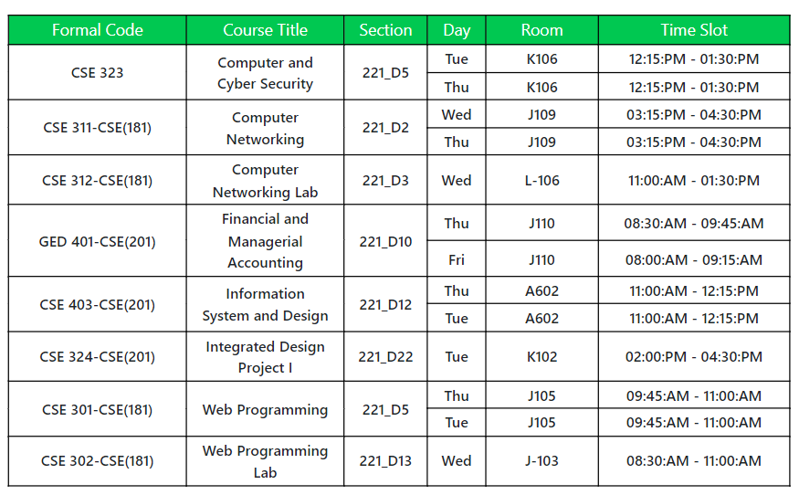

Fig1: My class routine

**3. PROCEDURE / ANALYSIS / DESIGN**

**Pseudocode:**

* Create an HTML document named "LabReport2.html".
* Inside the head tag, Set the title of the page as "Class Routine Using HTML".
* Create a table using the table tag, set border=1, cellpadding=10, and align=center.
* Inside the table tag, create the first raw using the tr tag.
* Since the first row is the table headings, create all headings using th tag.
* After the first row, create the second row, and inside that maintain rowspan.
* Similarly create rest of the rows.
* In the Lab courses there is only one day class per week, so no need for rowspan.

**4. IMPLEMENTATION**

HTML Code:

<html lang="en">

<head>

<meta charset="UTF-8">

<meta name="viewport" content="width=device-width, initial-scale=1.0">

<title>Cass Routine Using HTML</title>

</head>

<body>

<table border="1" cellpadding="10" align="center">

<tr>

<th align="center">Formal Code</th>

<th align="center">Course Title</th>

<th align="center">Section</th>

<th align="center">Day</th>

<th align="center">Room</th>

<th align="center">Time Slot</th>

</tr>

<tr>

<td rowspan="2" align="center">CSE 323</td>

<td rowspan="2" align="center">Computer and Cyber Security</td>

<td rowspan="2" align="center">221_D5</td>

<td align="center">Tue</td>

<td align="center">K106</td>

<td align="center">12:15:PM - 01:30:PM</td>

</tr>

<tr>

<td align="center">Thu</td>

<td align="center">K106</td>

<td align="center">12:15:PM - 01:30:PM</td>

</tr>

<tr>

<td rowspan="2" align="center">CSE 311-CSE(181)</td>

<td rowspan="2" align="center">Computer Networking</td>

<td rowspan="2" align="center">221_D2</td>

<td align="center">Wed</td>

<td align="center">J109</td>

<td align="center">03:15:PM - 04:30:PM</td>

</tr>

<tr>

<td align="center">Thu</td>

<td align="center">J109</td>

<td align="center">03:15:PM - 04:30:PM</td>

</tr>

<tr>

<td align="center">CSE 312-CSE(181)</td>

<td align="center">Computer Networking Lab</td>

<td align="center">221_D3</td>

<td align="center">Wed</td>

<td align="center">L-106</td>

<td align="center">11:00:AM - 01:30:PM</td>

</tr>

<tr>

<td rowspan="2" align="center">GED 401-CSE(201)</td>

<td rowspan="2" align="center">Financial and Managerial Accounting</td>

<td rowspan="2" align="center">221_D10</td>

<td align="center">Thu</td>

<td align="center">J110</td>

<td align="center">08:30:AM - 09:45:AM</td>

</tr>

<tr>

<td align="center">Fri</td>

<td align="center">J110</td>

<td align="center">08:30:AM - 09:45:AM</td>

</tr>

<tr></tr>

<td rowspan="2" align="center">CSE 403-CSE(201)</td>

<td rowspan="2" align="center">Information System and Design</td>

<td rowspan="2" align="center">221_D12</td>

<td align="center">Thu</td>

<td align="center">A602</td>

<td align="center">11:00:AM - 12:15:PM</td>

</tr>

<tr>

<td align="center">Tue</td>

<td align="center">A602</td>

<td align="center">11:00:AM - 12:15:PM</td>

</tr>

<tr>

<td align="center">CSE 324-CSE(201)</td>

<td align="center">Integrated Design Project I</td>

<td align="center">221_D22</td>

<td align="center">Tue</td>

<td align="center">K102</td>

<td align="center">02:00:PM - 04:30:PM</td>

</tr>

<tr>

<td rowspan="2" align="center">CSE 301-CSE(181)</td>

<td rowspan="2" align="center">Web Programming</td>

<td rowspan="2" align="center">221_D5</td>

<td align="center">Thu</td>

<td align="center">J105</td>

<td align="center">09:45:AM - 11:00:AM</td>

</tr>

<tr>

<td align="center">Tue</td>

<td align="center">J105</td>

<td align="center">09:45:AM - 11:00:AM</td>

</tr>

<tr>

<td rowspan="2" align="center">CSE 302-CSE(181)</td>

<td rowspan="2" align="center">Web Programming Lab</td>

<td rowspan="2" align="center">221_D13</td>

<td align="center">Wed</td>

<td align="center">J103</td>

<td align="center">08:30:AM - 11:00:AM</td>

</tr>

</table>

</body>

</html>

**5. TEST RESULT / OUTPUT**

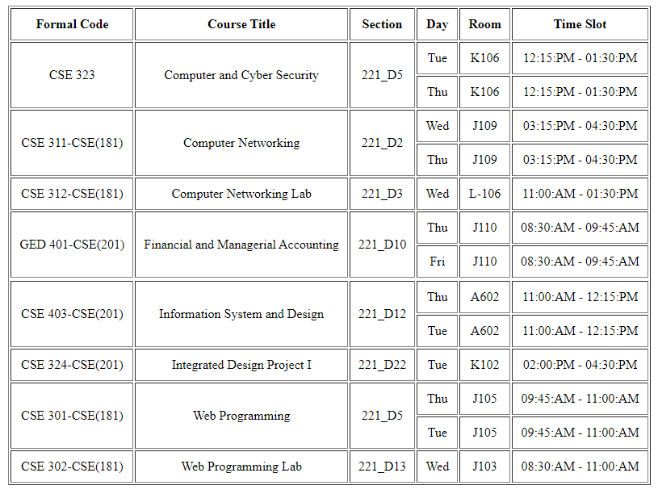

Fig2: Output

**6. ANALYSIS AND DISCUSSION**

I have already implemented most of the tags for the table in the lab class. I learned basic syntaxes for the table in the previous lab class. And I have implemented some simple tables in the class, from this I learned how to implement a simple table using HTML tags. From previous class learning, I implemented my class routine here. While implementing this routine, first I faced some syntax errors (I mistakenly placed some extra closing td tags). But I found the error and fixed it. After that, I faced no difficulties and completed my task.